In this document, I am going to show the workflow of Spring boot and AngularJS application .

I have used Spring boot 2.0.5 Release version.I have created a Spring boot AngularJS application which had AngularJS as user interface. It provided user interface from which you can add, update or delete customer database.I used controller, services and DAO classes to achieve these functionalities.I have connected to MySQL database using hibernate. Here Application is running on Tomcat server.

->This is the page which will come up in your default browser once I run an application.

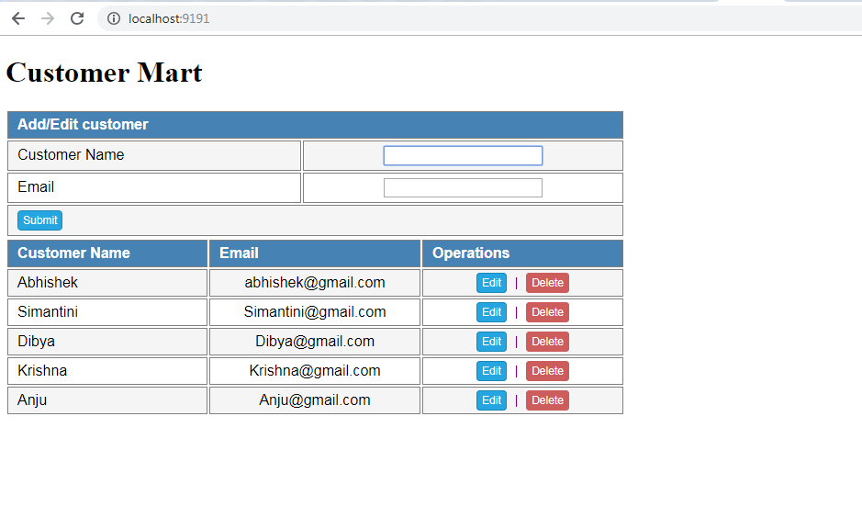

->From this page I can create new customer by giving the Customer Name and Email. When we click the submit button, new customer “demo” with the email insert into database.

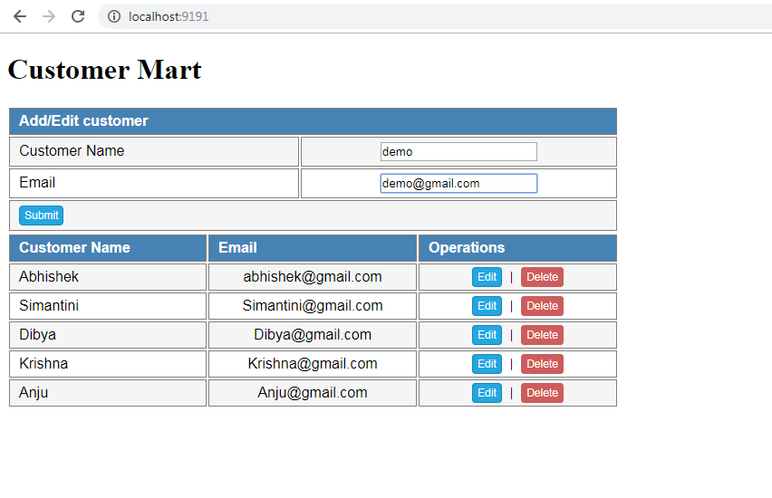

->Now Demo user inserted into database, which is listed in Customer Table at the end.

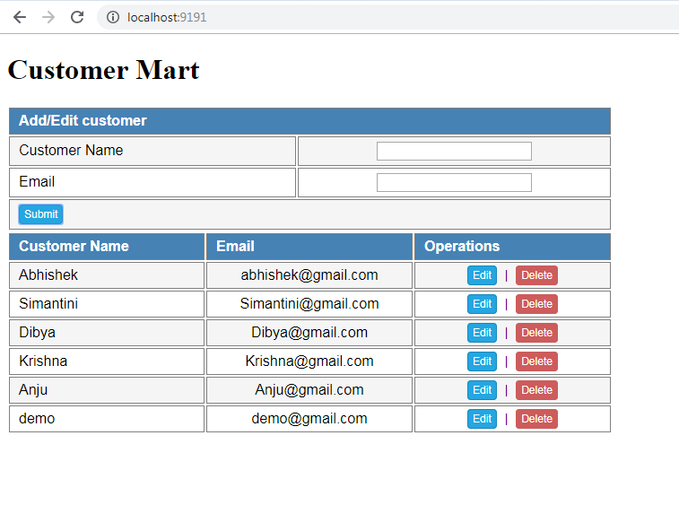

* I am going to edit the “Demo” user by clicking on Edit button, when I click on Edit button in the table, the user details copied to input fields where I can modify the records.

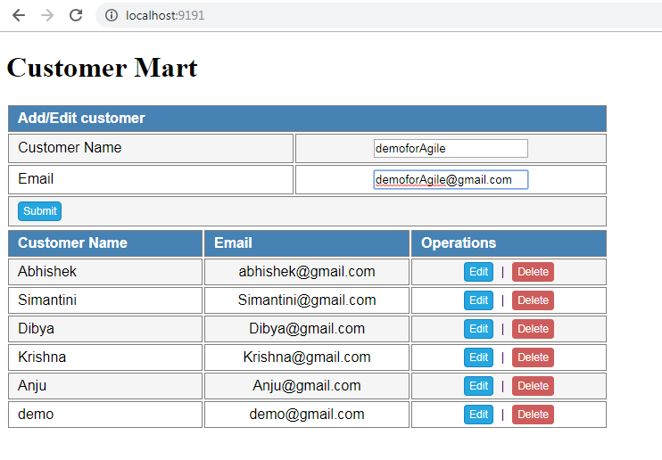

* After clicking on submit button, “demo” user which is modified to “demoforAgile” save into database.

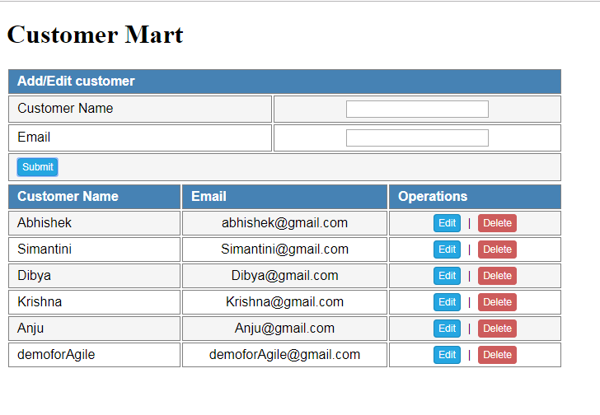

* Now I will go for delete operation. When we click on delete button, user will be deleted, which I did same for “demoforAgile” user details. Now demoforAgile is not available in table.

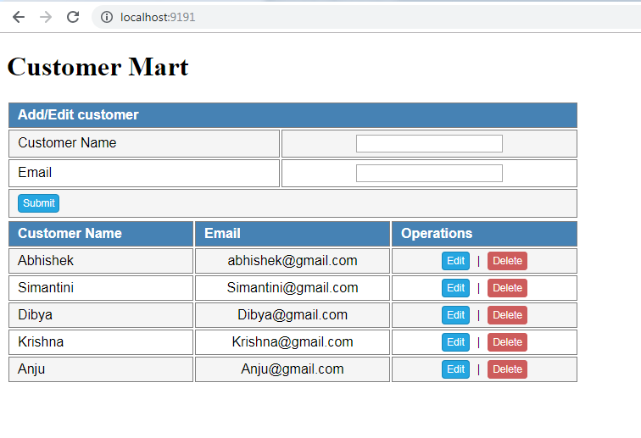

* This is the MVC architecture project workspace .

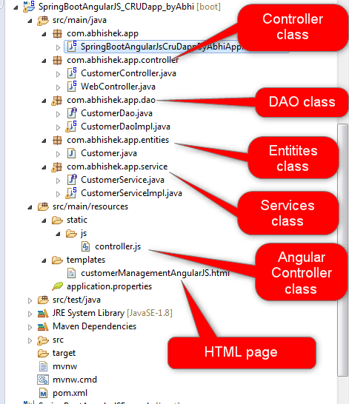

**Please feel free to ask any queries**.